QUAIL RIDGE MONITOR Vol. 18: November 2008 - 2009
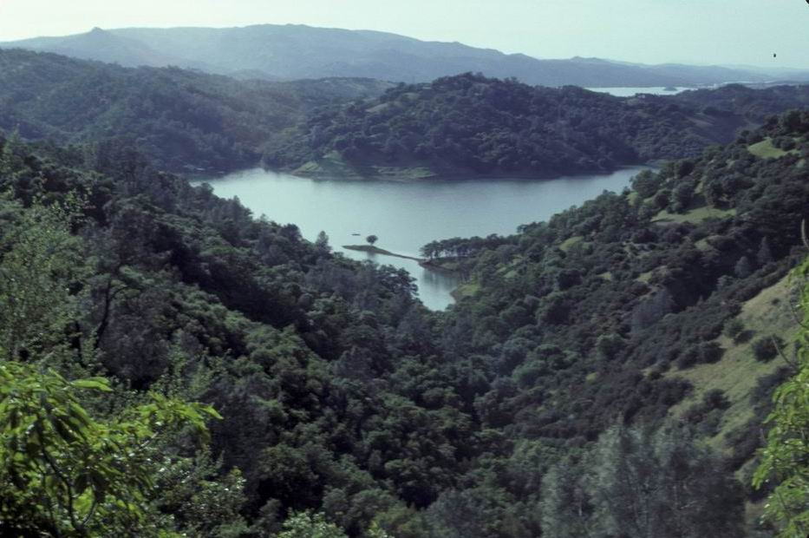 Photo courtesy of UCDNRS

Dear Members and Friends of QRWC,

As 2008 draws to a close, it is time for our annual update to Quail Ridge members and supporters. The past year has been eventful not only on the national scene but for us here at QRWC as well. First, we are happy and relieved to report that Frank Maurer, our Executive Director, pulled through a tough battle with lymphocytic leukemia, which hit him with astonishing rapidity almost exactly one year ago, requiring a month’s hospitalization followed by six months of chemotherapy and then intensive radiation for a secondary carcinoma. He has responded extremely well to the treatments and has a very promising prognosis for remission for a long time to come. In spite of this setback, he has continued to work steadfastly on protecting Quail Ridge Reserve and other wild land projects that he has become involved with.

Secondly, on the Reserve we are closer now to completing the purchase of the 120-acre parcel on the northeast boundary of the Reserve that had been bought in 2005 by a generous conservationist, David Welborn, who had agreed to hold on to the property temporarily to protect it but who wanted to be bought out eventually by a conservation agency or organization. This is now underway with funds provided through grants to the UCD Natural Reserve System by the California Coastal Conservancy and the Wildlife Conservation Board of California. These grants will also purchase the 37-acres property we call the Quail Ridge House, for which QRWC has been fundraising for 15 years. This means that, at last, these two parcels will be officially incorporated into Quail Ridge Reserve. Unfortunately, there is one down side: the grant awarded for the Welborn property falls short by $290,000 of the amount needed fully to reimburse the owner, so we are continuing to fundraise to fill that gap. Thus, as always, we need your help in this fundraising campaign, perhaps among our last major efforts for the Reserve. Some suggestions follow…

--For the coming year QRWC will be conducting joint hikes as outreach for other nonprofits. These could be used either
for education or for fundraising efforts of the participating groups.

--The Quail Ridge Gift Boutique has wonderful gifts for any occasion. Please look over the enclosed list. Two special
items to consider are Gary Snyder’s poems and our own Scottish poems read by local Scotsman Duncan McMartin.
Both CDs are lively and interesting.

--The resorts at Lake Berryessa are being reorganized and the person from whom QRWC rented its boat for our supper
cruises will be going out of business. We are not sure what will happen next year regarding the boats, but there is no
question but that our walks—both scheduled and as special events—will continue. Please get the word out to others:
we work with groups of all ages and backgrounds. Perhaps you would sponsor a group of your choice.

--Please also consider—in addition to a membership or renewal—a special end-of-the-year, tax-deductible contribution to
the Conservancy. This could rightly be considered an investment in a nearby part of California’s natural heritage, rapidly
disappearing from most parts of the state due to never-ending human population growth and development. Quail Ridge
Reserve is, quite simply, a living natural legacy for your children and grandchildren and for generations beyond.

Thank you for your past and continued support for Quail Ridge Wilderness Conservancy and Quail Ridge Reserve. As the year draws to a close, the QRWC Board wishes all of you a merry holiday season and a happy new year!

